**Jenkins tasks for Day-03**

1) **Create one jenkins job using the below code and create three stages.**

stage1: Git clone to download the source code.

stage2: Sonarqube Integration to check the quality of code

stage3: Slack Integration to send the alerts to slack.

URL: https://github.com/betawins/VProfile-1.git

* First Access to my Jenkins-master Dashboard then I created new job (sonarqube-job) in added a git URL

Url: “https://github.com/betawins/VProfile-1.git”

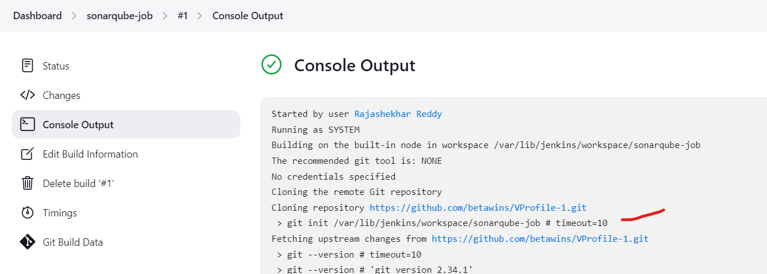

* Once created the job build it, after build the job workspace will created



* First created a new instance with t2.medium and with storage of 20 GB

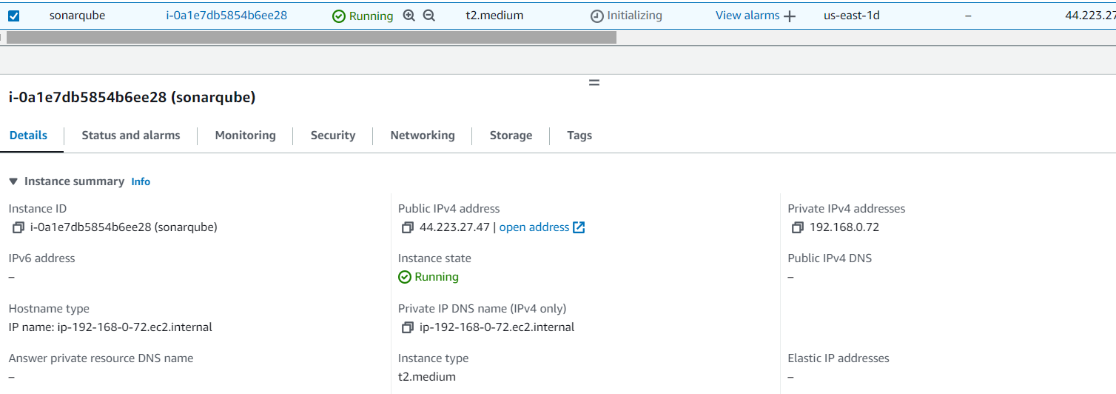

* install Java using “ yum install java-1.8*

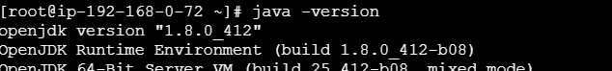

* Download mysql package using

sudo wget https://dev.mysql.com/get/mysql57-community-release-el7-11.noarch.rpm

sudo yum localinstall mysql57-community-release-el7-11.noarch.rpm



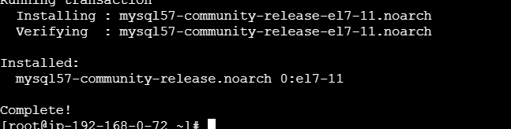

* Import the key using

rpm --import <https://repo.mysql.com/RPM-GPG-KEY-mysql-2022>



* Install the mysql community-server

sudo yum install mysql-community-server

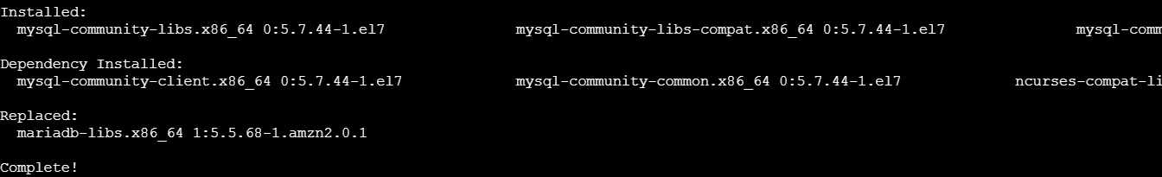

* Then start the mysql using

sudo systemctl start mysqld.service



Start MySQL and Enable Start at Boot Time using below commands

systemctl start mysqld

systemctl enable mysqld



* I have checked that mysql port is running or not using netstat -na | grep 3306



Configure the MySQL Root Password

We will see default MySQL root password

grep 'temporary' /var/log/mysqld.log



Login to mysql using the default password

mysql -u root -p

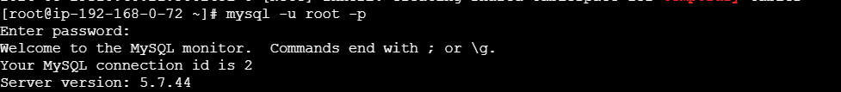

Now replace the default password with a new and strong password

ALTER USER 'root'@'localhost' IDENTIFIED BY 'Admin@123';

flush privileges;

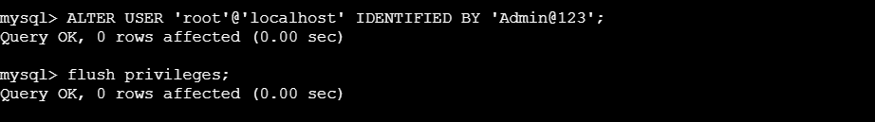

Tested Using new password , alogged in with new password

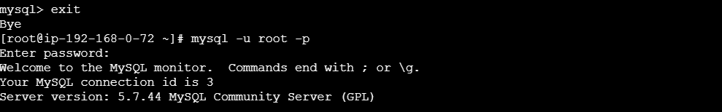

Download & unzip SonarQube 6.0

* change to “**/opt”**

Then Download sonarQube

wget <https://binaries.sonarsource.com/Distribution/sonarqube/sonarqube-6.6.zip>



unzip sonarqube-6.6.zip



* Rename the folder name

mv /opt/sonarqube-6.6 /opt/sonar



Login to mysql

mysql -u root -p

* Create a local and a remote user

CREATE DATABASE sonar CHARACTER SET utf8 COLLATE utf8_general_ci;

CREATE USER sonar@'%' IDENTIFIED BY 'Sonar@123';



Grant database access permissions to users

GRANT ALL ON sonar.* TO sonar@localhost;

GRANT ALL ON sonar.* TO sonar@'%';



**check users and databases**

show databases;

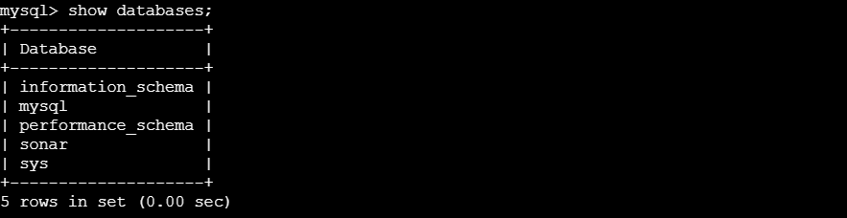

SELECT User FROM mysql.user;

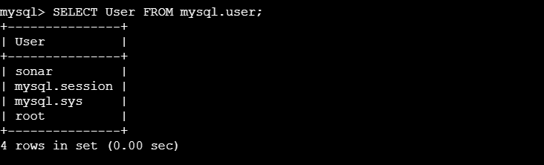

FLUSH PRIVILEGES;



**#ON EC2-Instance**

Edit sonar properties file to uncomment and provide required information for below properties.

- File Name: /opt/sonar/conf/sonar.properties

- sonar.jdbc.username=`sonar`

- sonar.jdbc.password=`Sonar@123`

- sonar.jdbc.url=jdbc:mysql://`localhost:3306`/sonar?useUnicode=true&characterEncoding=utf8&rewriteBatchedStatements=true&useConfigs=maxPerformance&useSSL=false

- sonar.web.host=`0.0.0.0`

- sonar.web.context=`/sonar

Start SonarQube service

# cd /opt/sonar/bin/linux-x86-64/

# ./sonar.sh start

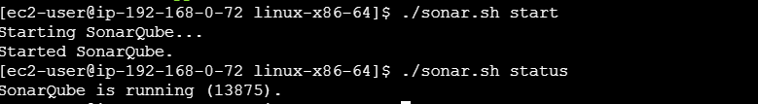

Logged into sonarqube

http://54.242.78.129:9000/sonar

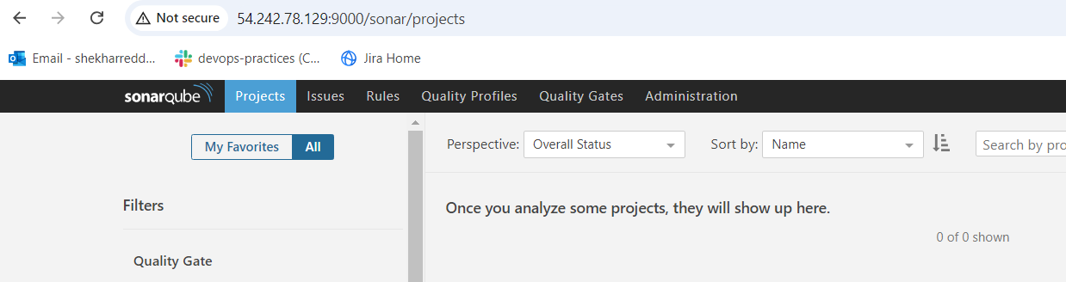

Then create a token in sonarqube

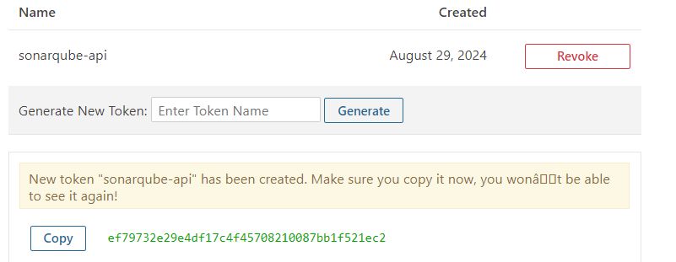

* To add the Global credentilas of sonarqube

Jenkins [Dashboard](http://54.165.95.20:8081/)→[Manage Jenkins](http://54.165.95.20:8081/manage/)→[Credentials](http://54.165.95.20:8081/manage/credentials/)→[System](http://54.165.95.20:8081/manage/credentials/store/system/)→[Global credentials (unrestricted)](http://54.165.95.20:8081/manage/credentials/store/system/domain/_/)

* Jenkins [Dashboard](http://54.165.95.20:8081/)→[Manage Jenkins](http://54.165.95.20:8081/manage/)→[Credentials](http://54.165.95.20:8081/manage/credentials/)→[System](http://54.165.95.20:8081/manage/credentials/store/system/)→[Global credentials (unrestricted)](http://54.165.95.20:8081/manage/credentials/store/system/domain/_/)

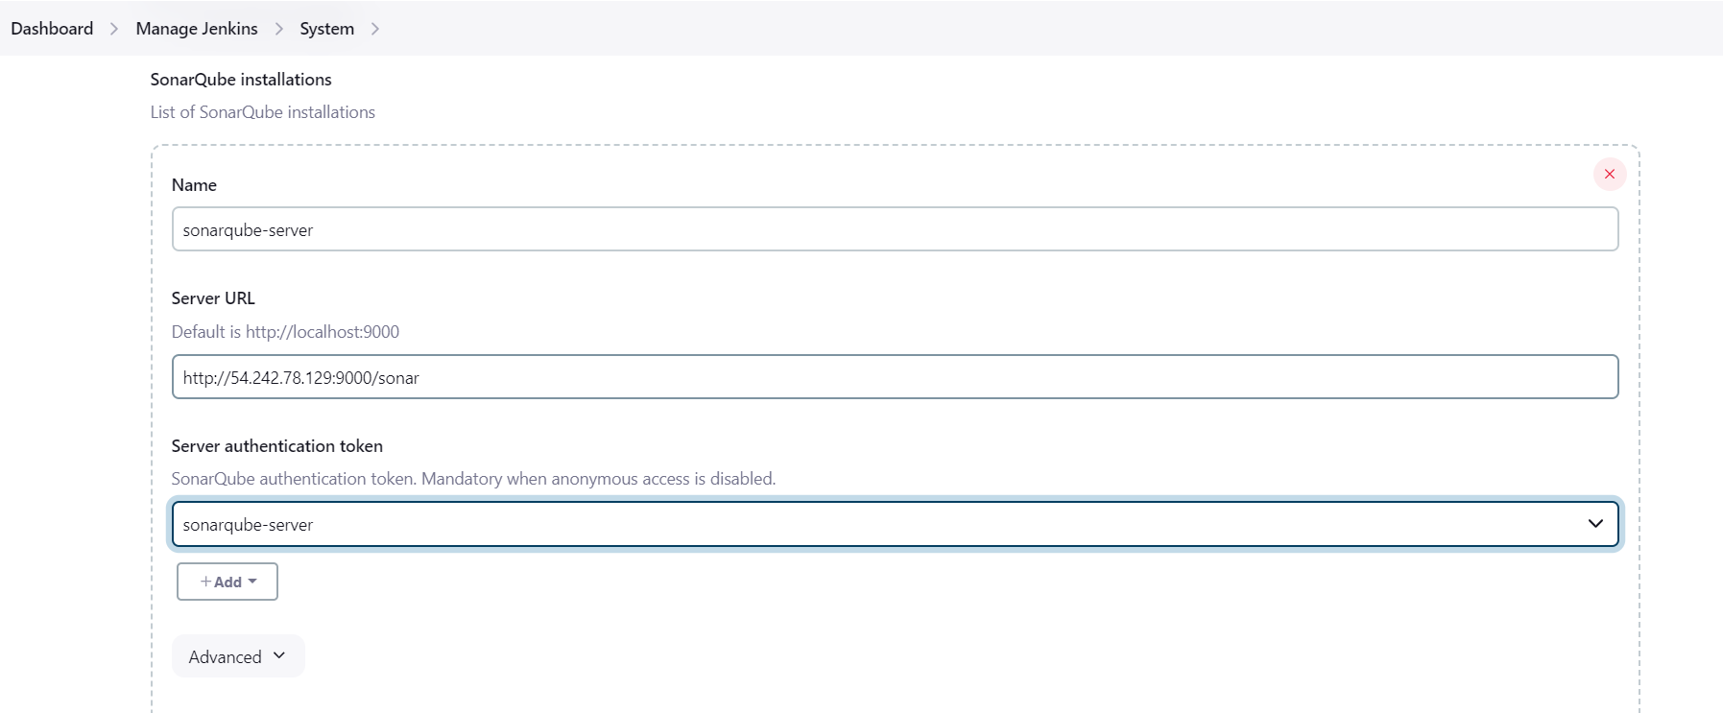

* Download the sonarqube-scanner package at opt folder in jenkins-server

wget https://binaries.sonarsource.com/Distribution/sonar-scanner-cli/sonar-scanner-cli-4.6.2.2472-linux.zip

unzip sonar-scanner-cli-4.6.2.2472-linux.zip



* Renamed mv sonar-scanner-4.6.2.2472-linux /opt/sonar_scanner



Set SonarQube server details in sonar-scanner property file

Sonar properties file: /opt/sonar_scanner/conf/sonar-scanner.properties

- sonar.host.url=http://`<SONAR_SERVER_IP>`:9000/sonar

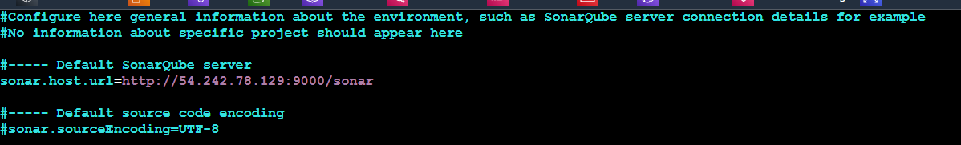

Configuring SonarQube scanner home path

**Manage Jenkins` > `Global Tool Configuration` > `SonarQube Scanner`**

**-** Name  **: `sonar_scanner`**

**-** SONAR_RUNNER_HOME **: `/opt/sonar_scanner/bin`**

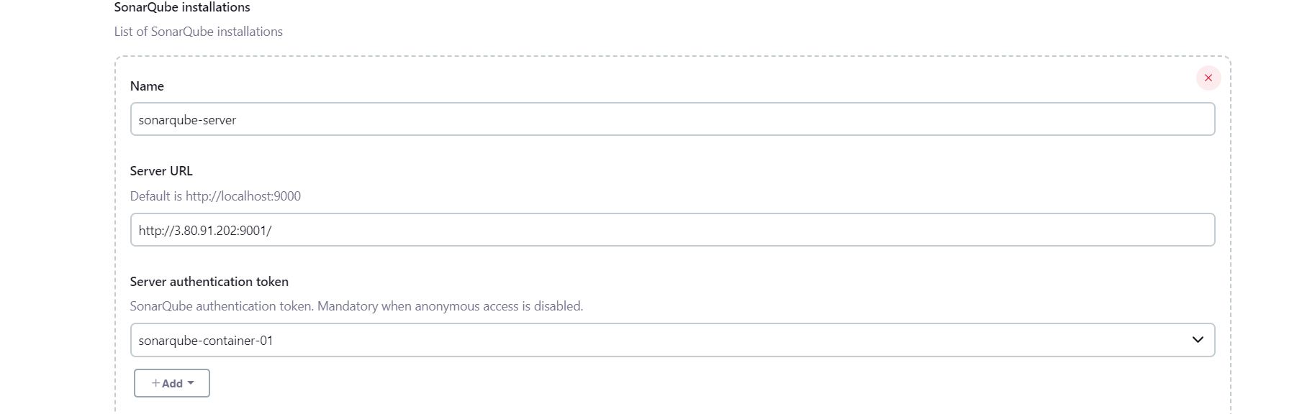

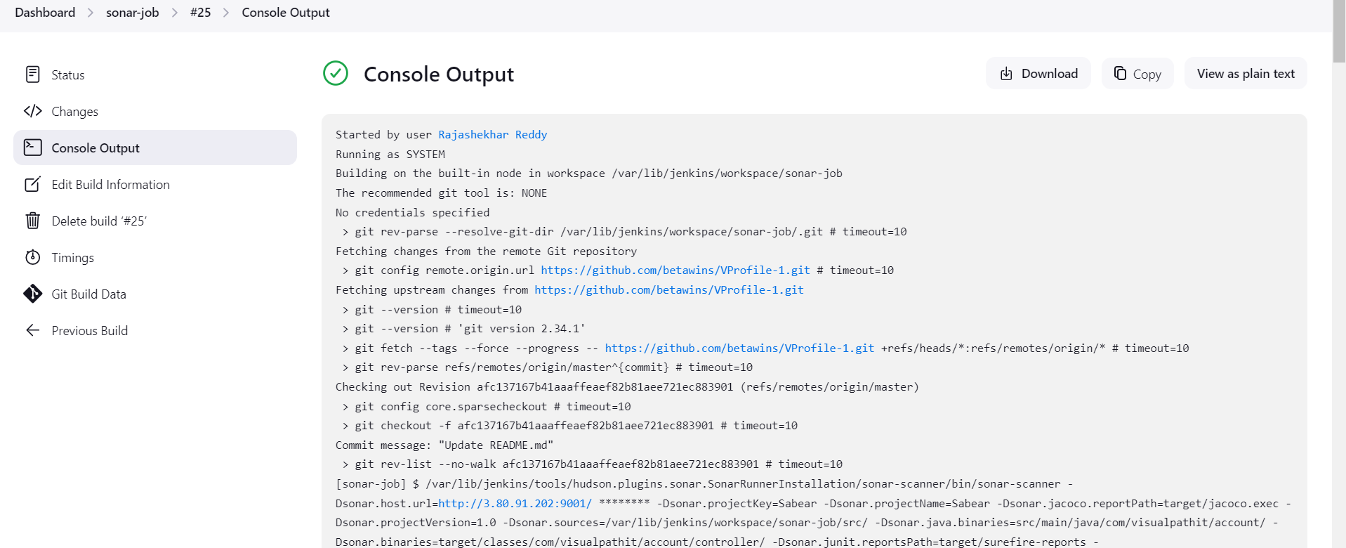

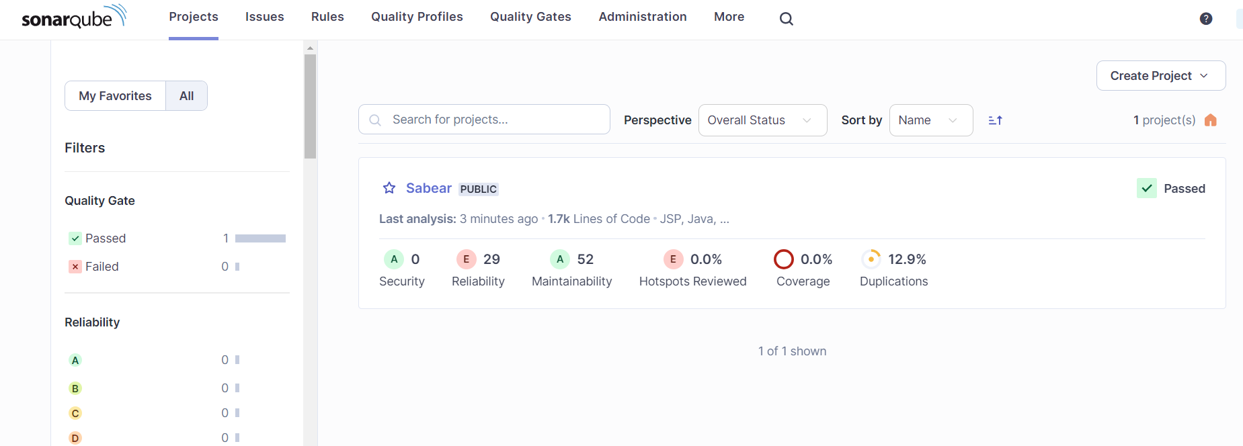

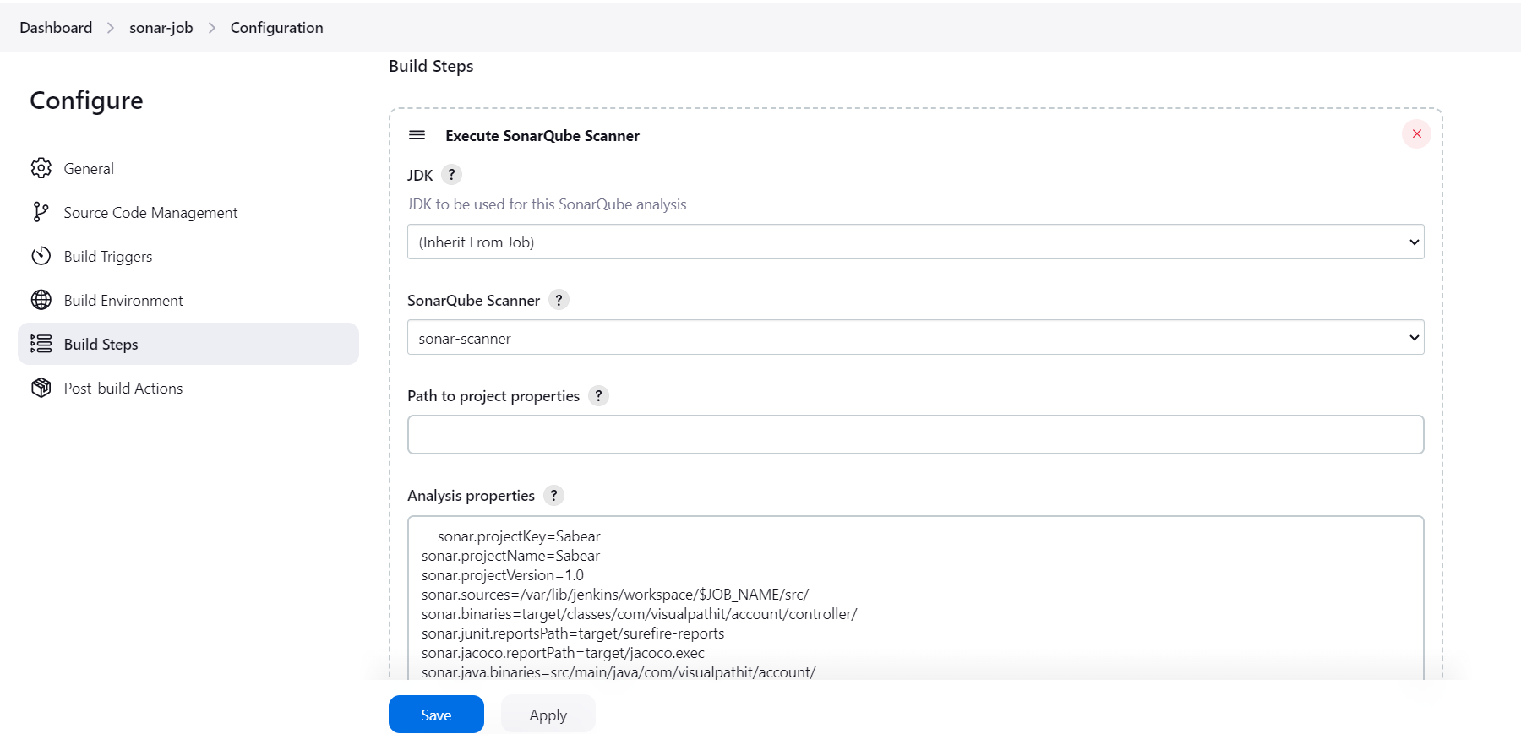

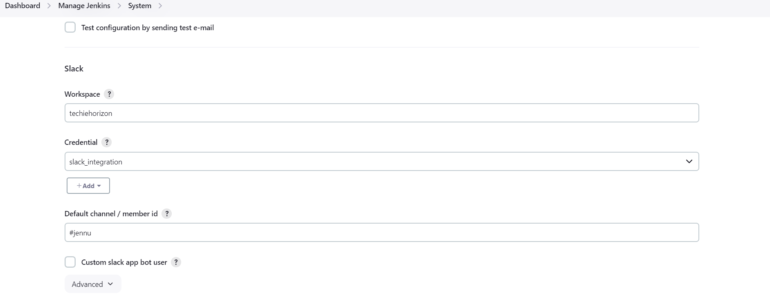

2) 1) Create one jenkins job using the below code and create three stages.

stage1: Git clone to download the source code.

stage2: Sonarqube Integration to check the quality of code

stage3: Slack Integration to send the alerts to slack.

URL: <https://github.com/betawins/hiring-app.git>

